

Preparation
1. The surface must be thoroughly cleaned and free of all oils, waxes, dust and dirt
2. On a flat table, with the application tape side up, use a squeegee or credit card to wipe over the whole of the lettering using plenty of pressure. This will stick the lettering to the application tape and release it from the backing paper.
3. Mark guidelines to the surface of the substrate, with a pencil.

4. Before removing any of the protective paper, Place the lettering/graphic accurately on the surface. Use a wide strip of masking tape to stick the top edge to the surface. This becomes a hinge
 | 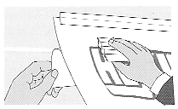 | 5. Lift the lettering/graphic, pull back and cut away the top section of the backing paper  6. Holding the base of the lettering/graphic, allow it to return to its original position.
7. Using the squeegee and light pressure, start from top center and with horizontal strokes, apply the vinyl. Carry on this way removing sections of backing each time. (for large signs this can be done in sections between letters)
8. After removing all the backing paper you can apply more pressure.
9. Leave for 10 minutes
 | 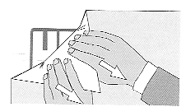 | 10. Once you are sure the vinyl is securely attached to the surface, remove the application tape diagonally at a 180° angle back over itself then rub the entire graphic with a soft cloth paying particular attention to the edges.
11. Remove any air bubbles by puncturing the bubble at one edge with a pin, then squeegee the trapped air towards and out of the puncture.
Can also be applied using a bottom hinge if preferred.

With pressure sensitive vinyls the harder you press, the more they stick. Also the longer you leave them, the more they stick. Allow the decal to sit for at least 24 hours for the adhesive to completely set up. You can then re wax around the lettering if needed.

Visit domednumbers.com/install for a short video

Thank you for the order!
We would love to hear your feedback
and we also need your help with photos for our product images and gallery!

Please share to orders@customdoming.com or tag us on social media.

